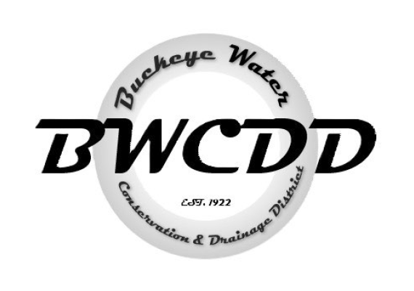

BUCKEYE WATER CONSERVATION
&
DRAINAGE DISTRICT
Pursuant to A.R.S. § 38-431.02,
NOTICE IS HEREBY GIVEN
that a meeting of the Board of Directors of the
Buckeye Water Conservation & Drainage District
will be held on Monday, February 23, 2026 starting at 11:00 am,
at the offices of
Buckeye Water Conservation & Drainage District
205 E. Roosevelt Ave. Buckeye, Arizona 85326.

*The board meeting minutes, financials, and executive session documents will be sent in two separate emails prior to the meeting.

