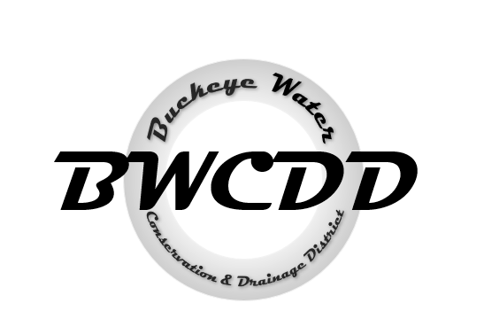

**BUCKEYE WATER**

**CONSERVATION**

**&**

**DRAINAGE DISTRICT**

**Pursuant to A.R.S. § 38-431.02**

NOTICE IS HEREBY GIVEN –

that a Special Called Board of Director’s meeting of the Buckeye Water Conservation & Drainage District (“BWCDD”) will be held on:

**DATE:** Monday, January 6, 2025

**TIME:** 11:00 a.m.

**ADDRESS:** Buckeye Water Conservation & Drainage District

205 E. Roosevelt Ave. Buckeye, Arizona 85326

*\*The Special Called Board of Director’s meeting agenda will be sent in a separate email prior to the meeting.*